The ContinU Plus Academy

The uniform At ContinU Plus Academy is supplied for your child. We ask for a donation of £40 towards the uniform.
The boys’ uniform is a tracksuit and T shirt, the girls’ uniform is leggings and a T-shirt. Both uniforms have been chosen by the pupils.

Boys uniform
Tracksuit – Nike T-shirt’s – Nike Red or
Black
Boys 12 -13 Boys 12 -13
Boys 13 -14 Boys 13 -14
Adult Small Adult Small
Adult Medium Adult Medium
Adult Large Adult Large

The ContinU Plus Academy

Girls uniform
T-Shirts – Adidas Leggings Adidas

Size 6 Size 6
Size 8 Size 8
Size 10 Size 10
Size 12 Size 12
Size 14 Size 14
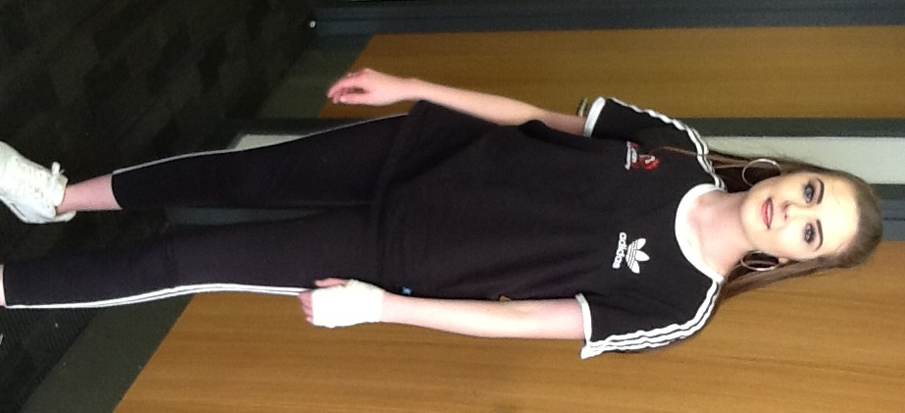
Size 16 Size 16

